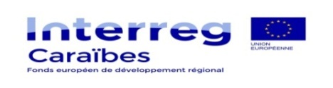
Project summary sheet – INTERREG Caraïbes

Project | Project name, acronym
SYNERGIE n°
Axis
Specific Objective
Lead partner | Nom de la structure, public/privé, localisation
Project partners | European partners:  - Name of the organization, public/private body, location  Non-European partners :  - Name of the organization, public/private body, location
ERDF support applied for
EDF support applied for
Project total amount
Total eligible cost

Project’s description:

Targeted objectives and expected results:

Planned activities:
Activities planned through an ERDF support
Activities planned through an EDF support

Description of the project team:

Indicators :

Budget :
Extract tables « consolidated resources » and « consolidated expenditure » from the application form budgetary annex.

Major supporting documents included in the application package | Comments and provided documents
☐ Lead partner status
☐ Engagement letters for the project partners
☐ Quotes
☐ Supporting documents for staff costs
☐ Cofinancing supporting document (public an private bodies)
☐ Documents supporting for the project holder’s self-financing capacity
☐ Supporting documents for the project holder’s financial capacity

